How to Make a Tutoring Appointment for the Writing Center
  - Summer 2024 Edition

Step 1: Log in at loyola.mywconline.com (Note: Remember that GoogleChrome and Mozilla Firefox work best with WCOnline Loyola)

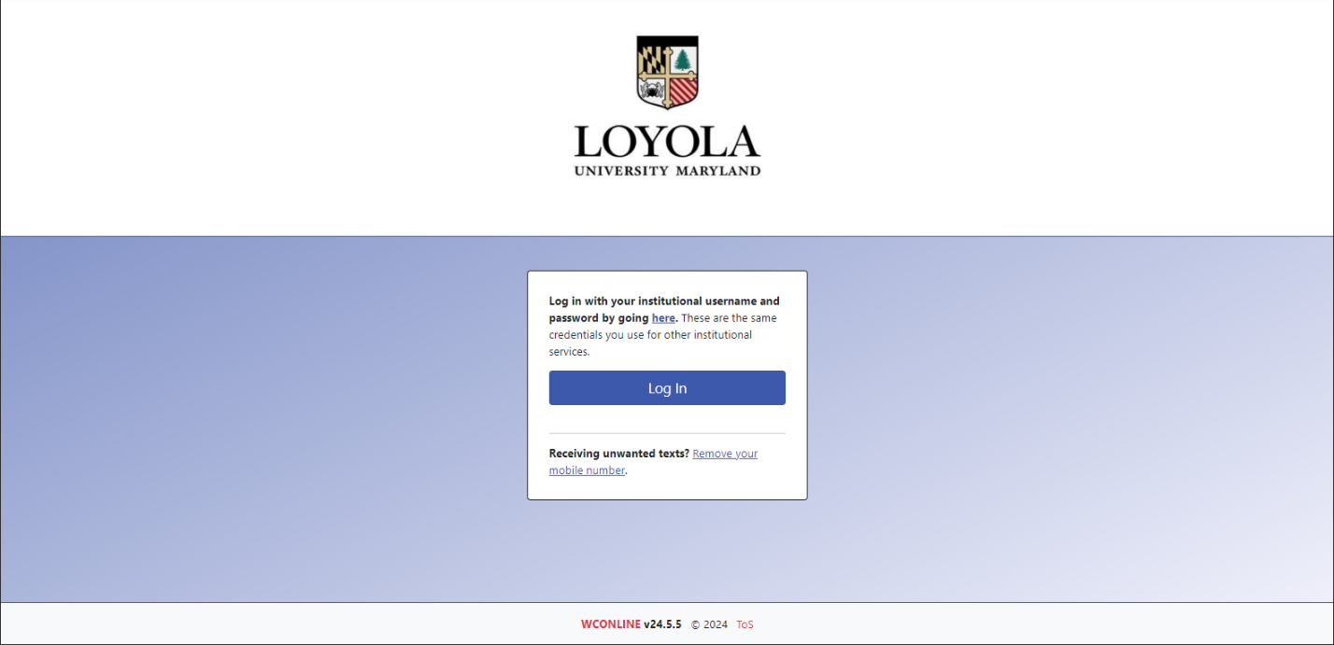
Step 2: Select the Writing Center Summer 2024 Link

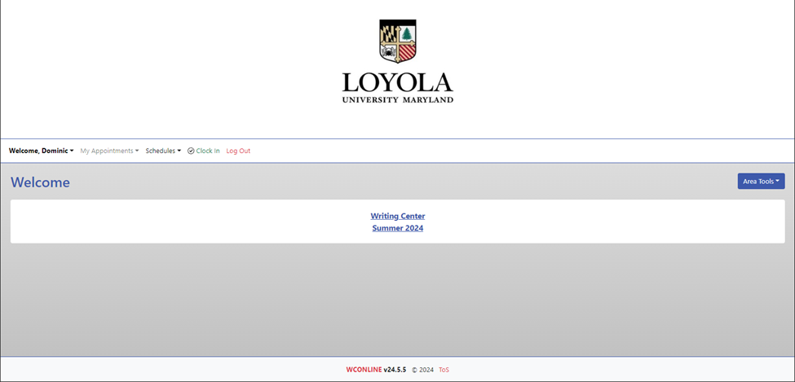

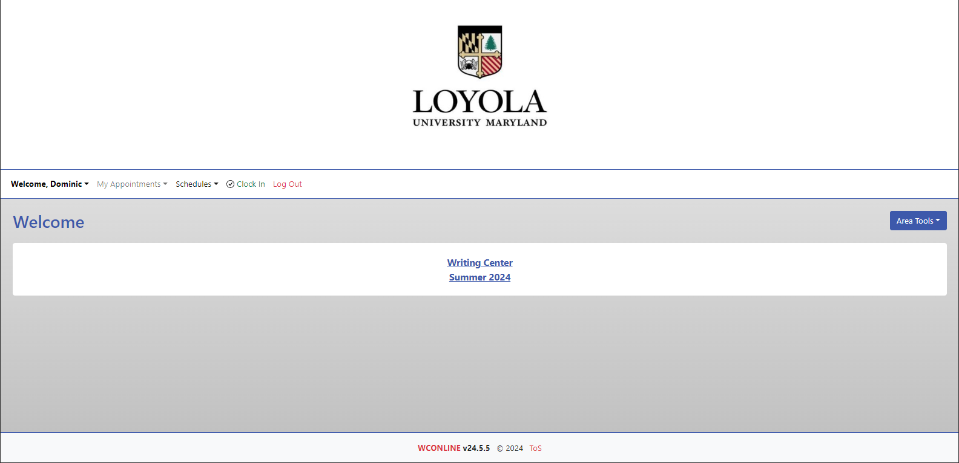
Step 3: Select the Calendar View from the Blue Area Tools Button.
Calendar Display (recommended):

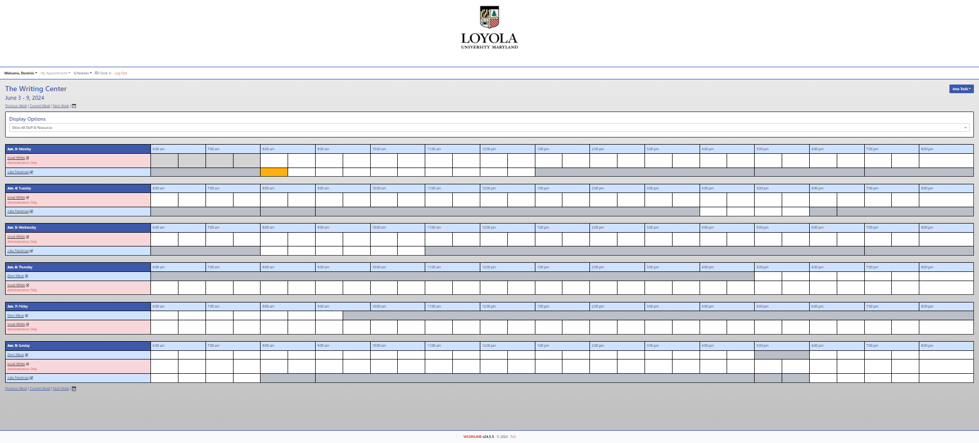

Step 4: On the Calendar View, look at your options and choose a time by clicking inside one of the uncolored boxes.

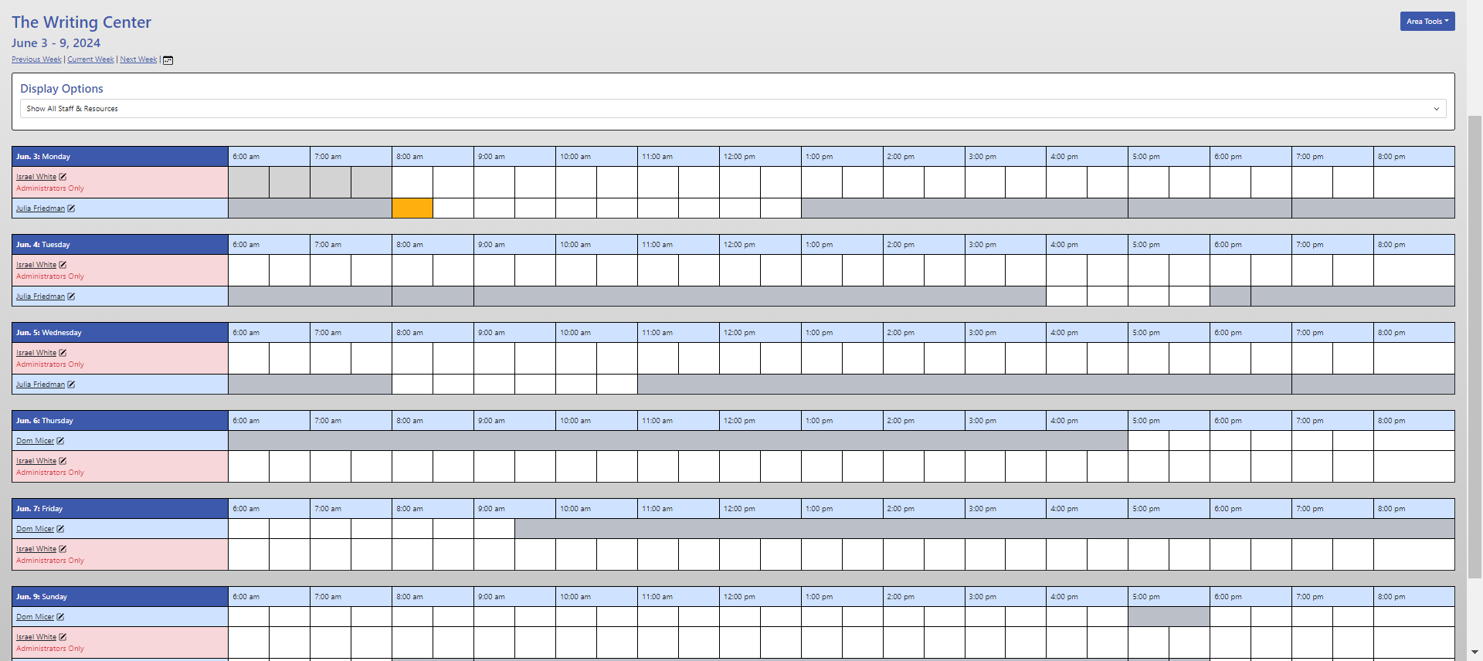

Step 5: Answer the necessary questions and upload any papers ahead of time.

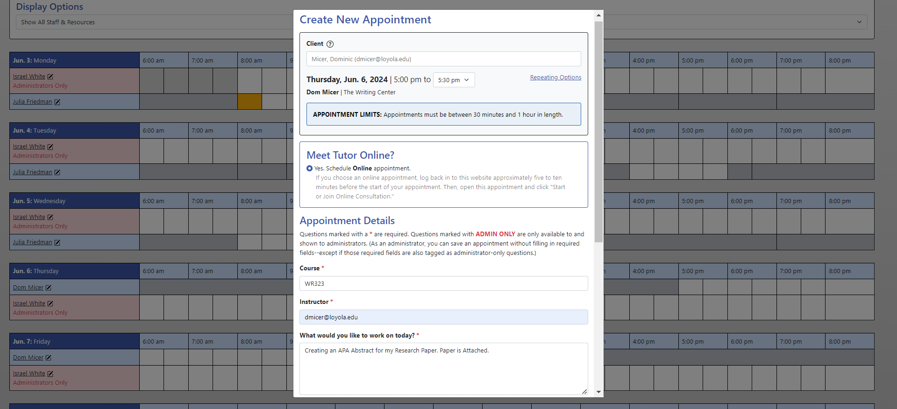
Step 6: Add a file if necessary and click the Blue Create Appointment Button.

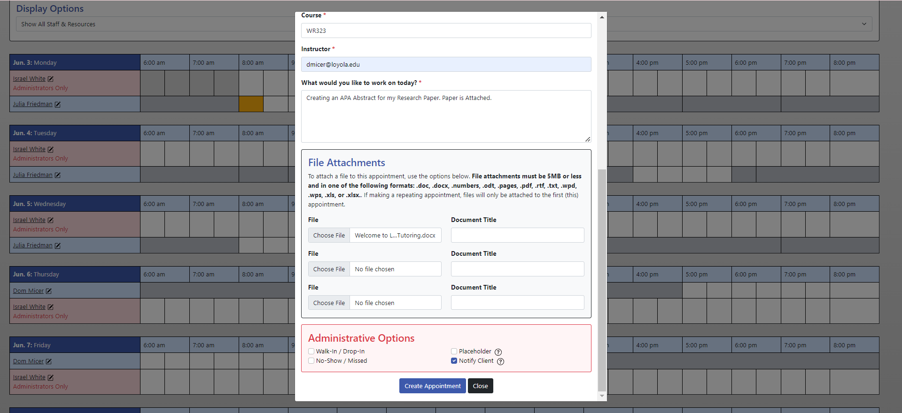

Step 7: Verify the Information is Correct. If you need to edit the appointment, click the blue Edit Appointment button and follow the directions. If you need to cancel the appointment, click the red Cancel Appointment button and follow the directions.

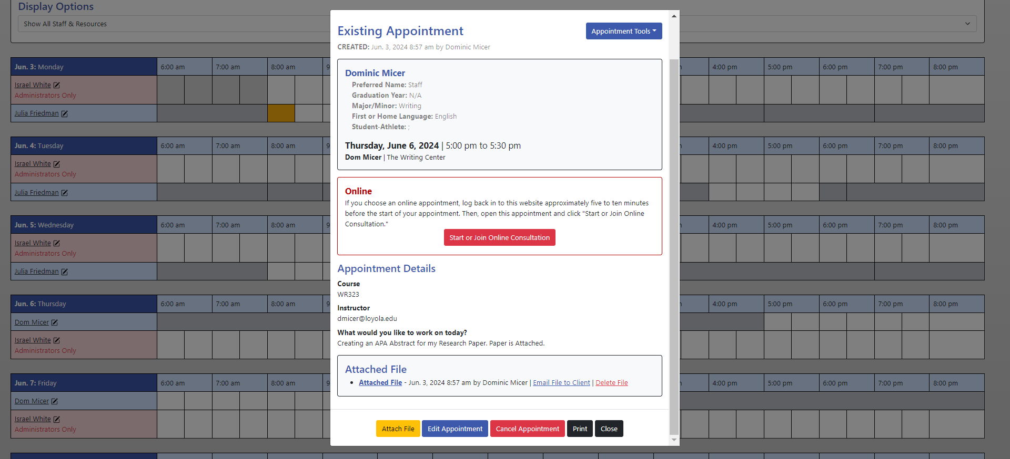
Step 8: Check your email or text messages for the appointment notification.

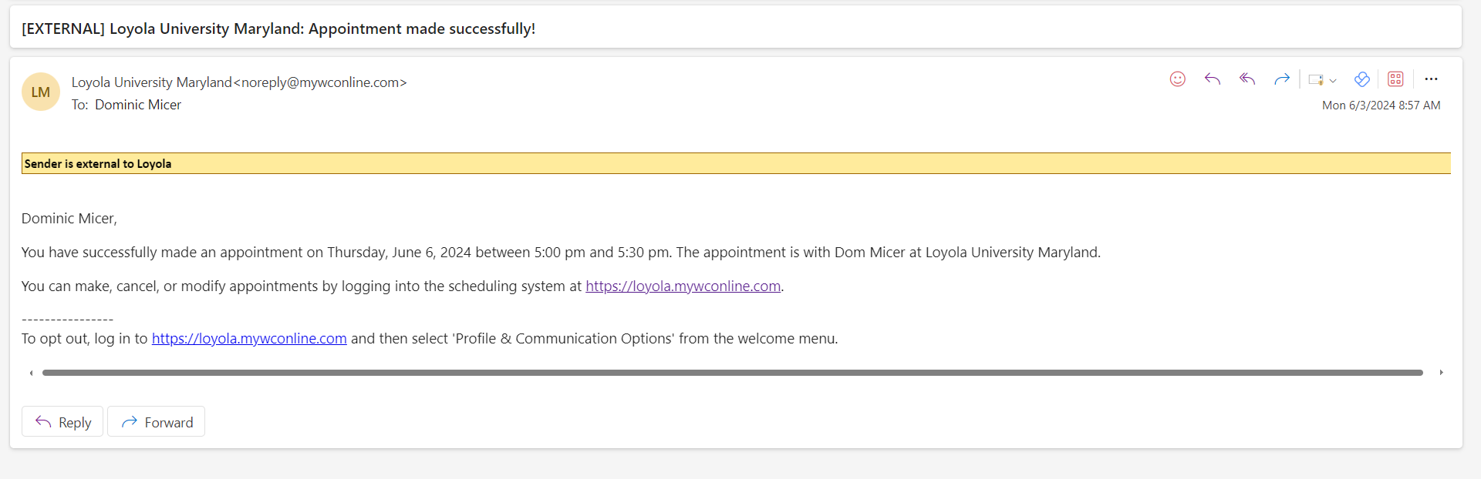Step 9: Click on the link in email to log in to WCOnline and meet your appointment.

