WCOnline Account Setup & Log-in
Welcome to Loyola University Maryland Writing Center Graduate Summer Tutoring
This section will go through how to set up an account on WCOnline and Log in after account setup.

General WCOnline Tips
- In many places throughout the WCOnline site, you will see a small blue bubble with a question mark: When you see this, you can hover your mouse over the bubble to get more information about that particular feature or option.
- WCOnline can be used on a computer browser or on a mobile device. On your computer, WCOnline works best with Google Chrome and Mozilla Firefox. More information about phones, soon.

Account Set-up
- Navigate to https://loyola.mywconline.com/. Please bookmark this page for future ease of access.
- For your first login, choose the “Log in with your institutional username and password by going here” link:
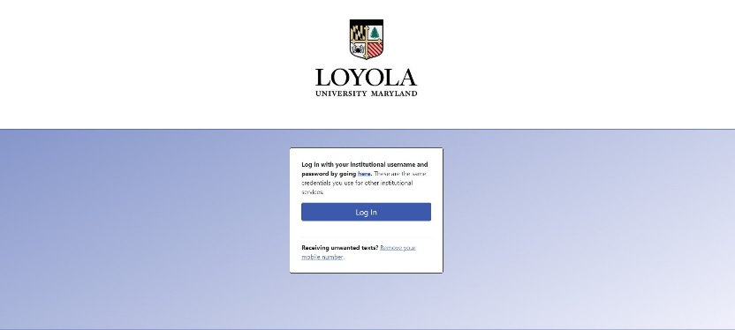
- Fill in all of the necessary elements on the form labeled with a red asterisk:
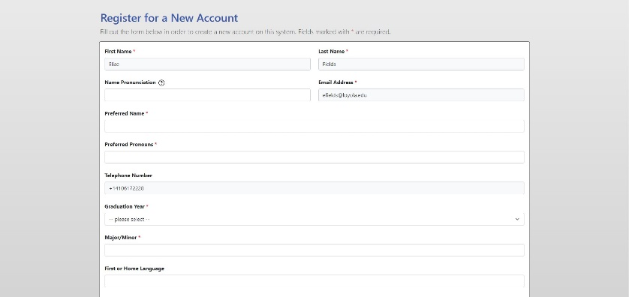
- At the bottom of the screen, choose your communications preferences (for example, if you only want to receive email reminders of appointments, do nothing; if you want text message reminders, put in your details).
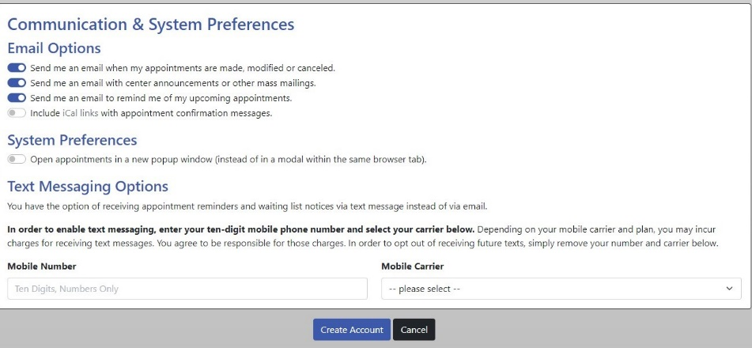
- Click the Create Account button to finish creating your WCOnline Account.

How to Log in
- Proceed to Loyola.mywconline.com and it will take you here:

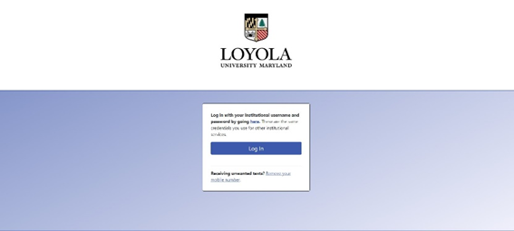
- Click the Blue Log in button, and it will take you here:
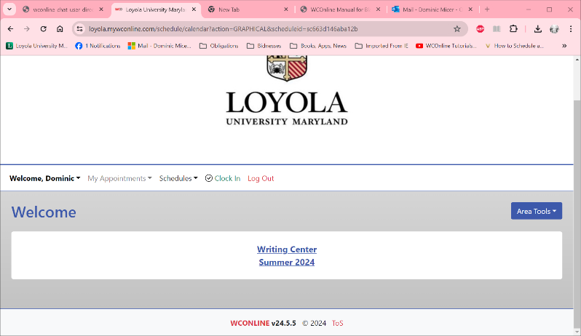
- Click on the Writing Center Summer 2024 Tab to make an appointment (see the Making an Appointment Handout for further instructions).

