The Roman Conceptualization of Peace through Tradition and Order:

Significance of Ancient History for Contemporary Peace Studies

Hannah Faith Lee

TH 401: Peace and Justice Capstone

Professor John Kiess

May 4, 2020

The Roman Empire marked a time in human history that contributed substantially—directly and indirectly—to the advancement of our sociocultural evolution. Whether by Romanizing Greek culture or introducing new contributions, we can learn from how the Romans perceived the best way to function successfully as a society. More specifically, analyzing how Romans conceptualized and constructed *peace* can benefit us develop new ways to organize and build peace today.

In ancient Rome, peace was by no means interpreted or practiced as it is today. The Romans, for instance, did not recognize modern moral principles like human rights or social justice. In a culture fueled by tradition and order, it was solely within the balance of the two that cultivated, what I will call, ultimate peace for the Roman Empire. Peace through tradition was successfully upheld if Romans collectively committed to traditional family values and societal expectations of them. As for order, peace was absent when Romans did not have control over themselves or others. Furthermore, within this understanding of peace is *pietas*, or the network of obligations one has to all networks of their life—family, friends, religion, society, state, etc. Roman *pietas* was the cornerstone of Roman morality and the glue of Roman social relations. It was the societal expectation of every Roman to uphold their respective obligations to ensure order in and success of the empire.

I argue, then, that one’s will to preserve tradition and maintain control as well as one’s duty to uphold the societal obligations expected from each sphere of one’s life (*pietas*)ultimately defines what constitutes peace for ancient Romans. If these spheres are traditionally maintained by every Roman, ultimate peace will transpire: peace in the household (family and legacy), society (class and religion), and throughout the empire (dutiful service and imperialism). Arguably, however, all elements within this definition of ultimate peace were virtually never sustained altogether for a long period of time in Roman history. This ultimate peace is, ideologically, the perfectly functioning empire to which Rome aspired.

Today, we can learn from and reflect on the Roman structural, social phenomenon of ultimate peace. The ancient world seems to be a particularly untapped time for reflection in the field of peace studies. As a whole, peace studies tends to arise out of current events and focus on contemporary case studies. Consequently, very few peace theorists engage in the ancient world. Using this Roman structural conceptualization of peace offers a holistic, multiple-level approach that can benefit peace studies. Two prominent figures in the field of piece studies, John Paul Lederach and Daniel Philpott, use structural frameworks to navigate peacebuilding in *Building Peace: Sustainable Reconciliation in Divided Societies* (1998) and reconciliation in *Strategies of Peace: Transforming Conflict in a Violent World* (2010), respectively. Although both frameworks succeed in organizing the author’s respective arguments and indeed share similarities with the Romans’ framework of peace, they can further benefit from the Roman perception of peace. The field of peace studies is seemingly captive to the present moment, not realizing it can benefit greatly from history.

This analysis requires set boundaries, however. The Roman Empire went through many changes throughout its long history, most notably the transition from Republic to Principate in 27 B.C.E. and from polytheism to Christianity in 312 C.E. Even though many of the themes I will be discussing remain relatively consistent despite the transition from Republic to Principate, there are others that are more prevalent in one than the other that will be pointed out. Furthermore, Christianity’s impact on traditional Roman thought and ruling gradually transforms the empire at its core. For this reason, my analysis will remain strictly within these two time periods: from the foundation of the Roman Senate in 509 B.C.E. to the transition into a Christian empire under the reign of emperor Constantine the Great in 312 C.E.

Furthermore, it is important to mention that although the values I will be addressing were important to all Romans, most Roman experiences I refer to were primarily of the elite unless otherwise noted. The ancient texts that survive today give little insight into the lives of the majority, meaning a lot of Roman discourse (until relatively recently) has only reflected upper class experiences. Most importantly, however, tradition was important to all Romans and all Romans likely grasped that the empire succeeded through order and control, regardless of the fact that they themselves were being the controlled.

***

*Family*

The family was the basic unit of order in the Roman Empire. Jennifer Rae and Liz Clarke note that “the Roman family functioned like a smaller version of the Roman state.”[1] All order began in the family, for if no appropriate morals and traditional knowledge were recognized within the household, then everything else subsequently would fall out of order outside of the home. This familial order was governed by the oldest male in the household (the *paterfamilias*), who had complete “legal, social, and religious control over all of his household members.”[2] For example, as father, the *paterfamilias*’ children were legally dependent on him until his death unless “he chose to release them from his power,” for instance, “by transferring daughters to the family of their husband on marriage.”[3] The *paterfamilias* held the ultimate power over the home to assure order both within and outside of the household.

The *paterfamilias’* responsibility to uphold a moral, traditionally functioning family was socially important to the family’s reputation and especially the family’s contributions to society. Maintaining a good reputation was extremely important to Romans. More importantly, Romans wanted their family names to have meaningful, lasting legacies through the preservation of an honorable reputation. They understood that if members of a family were not contributing to society that they would not leave behind a worthy legacy: either a familial legacy through the name’s ancestral line and family tradition or a more tangible legacy by impacting Roman society in some way (in politics, literature, military exploits, etc.). This societal responsibility ultimately fell on the *paterfamilias*. If one of his children was morally corrupt, for example, the fault in this tainting of the family’s reputation fell on the father.

As an illustration, the third century C.E. Christian martyr Vibia Perpetua writes in her passion account about her father’s feelings toward her Christian identity. Her father constantly begged her to neglect her identity as a devoted Christian (no less a powerful leader in her Christian community), for he knew that both her “immorality” and his inability to control her would dishonor their family name. In Perpetua’s account, she reported her father as saying,

don’t dishonor me publicly. Consider your brothers, consider your mother, think of your maternal aunt, think of your son, who will not be able to live without you. Bury your pride, do not destroy us all: for none of us will speak freely if you suffer punishment. [4]

Rea and Clarke explain further saying, “from her father’s perspective, her rebellion against the traditional ways of doing things was a violation of social norms that could lead to serious consequences for him and the rest of the family.”[5] Furthermore, emperor Augustus exiled his granddaughter, Julia the Younger, for having an extramarital affair with a senator. It was his responsibility as the *paterfamilias* to rid any immoral behavior that would tarnish their family name.

Under the *paterfamilias*, it was essential that each member of the family played their part in assuring their orderly place in society. Children were tasked with one of the most important duties of the family: to maintain or advance their social standing. For elite families in the senatorial class, for instance, class “membership had to be re-earned in each successive generation” so children were raised under the expectation that they were to maintain the family’s success in adulthood. For example, a son was expected to get “elected to senatorial office” and a daughter was expected to “marry within her class [and] foster by her own activities the political ambitions of her brothers and sons.” For poorer families, children were obligated to provide for the household and contribute to the “improvement of the family’s status.” Children were likely seen as investments for poor families. At a young age, children’s labor can be beneficial toward the success of their family’s shop or farm. Also, if the parents had the funds to train their children “through apprenticeships,” children could “bring some income to their families once they became skilled.”[6] Poor children also had the opportunity to advance themselves (and their family) socially and financially by enlisting in the military. Anyone that survived the military was given “a modest amount of land” and the ability to “retire as a privileged group.”[7] These veterans oftentimes brought their families to live with them on this land, furthering their social status as a family unit.

Ultimately, order in the empire started with the family. Each member of the family was important to the legacy of their family as well as the ability to remain relevant in society by contributing to its order. A lot was at stake for Romans. If a family moved to a lower social status, for example, life would become significantly worse. The majority of Romans lived in harsh and oftentimes violent situations. If an elitist person were to disgrace their family, the family faced repercussions not only by being shunned by their elitist peers, but by losing the benefits of being elites. Therefore, it was essential that traditional values and practices be upheld and, in doing so, contribute to society.

***

*Society*

The elites maintained the order of empire by the reinforcement of social class.Romans understood that order and overall “well-being of the state” required that “the people always be dependent on the advice and authority of the ruling class.”[8] There are many ways that the Romans assured that society was rigidly hierarchical, allowing social advancement primarily on their terms. First, citizenship and all its benefits were restricted. Until the Edict of Caracalla in 212 C.E., which granted citizenship to all free men living in the Roman Empire, citizenship had to be bought unless one was born into it. The rights of citizenship, like “personal freedom,” ability to “own, legally protect, and exchange property,” and rights “to vote and to hold office,” were limited to those who could afford it.[9] Therefore, until 212 C.E., most of those living in Rome’s territories did not enjoy the same privileges that those living in the city of Rome did.Second, there was little opportunity for upward mobility in Roman society. Only the wealthy could afford proper education for their children, so most people did not have the tools to advance themselves. Slaves and those who served in the military were the only ones who had genuine opportunities to advance in social class.Slaves could earn their freedom. Oftentimes slaves worked as apprentices and became expertly skilled in certain trades. Upon earning their freedom, slaves could make a life for themselves as freedmen. Furthermore, as mentioned previously, those who survived serving in the military were granted a plot of land and better social status. Soldiers could advance themselves in rank in the military, which for centurions (high-level officers), for example, paid very well. This also opened doors for political opportunities. Power was limited to a small population. This was purposefully set so that the masses remained dependent on the elite. Ultimately, public harmony came from class dependency and order.

Another societal responsibility of all Romans was religious devotion, the lack of which could disturb the peace of the empire. Religion was interwoven with all elements of life. The gods were responsible for everything, including day-to-day activities, weather, political campaigns, and military exploits.The *pax deorum*, or “peace of the gods,” was an ideal “central to the ancient Roman commonwealth.” *Pax deorum* had a “contractual and reciprocal” relationship about it: “Romans provided the desired worship, veneration, and cultic observances; the gods in turn, it was hoped, safeguarded Rome’s public well-being.”[10]Therefore, if the gods were not placated properly and plentifully, the gods could adversely respond.All disasters, whether natural or manmade, were “seen as primarily theological events.”If disaster would occur, Romans blamed themselves or their leader(s) for lack of religious piety and proper placation rites. Jerry Toner writes, “The very fact of disaster was proof of the gods’ displeasure and demanded that attempts be made to placate them.”[11]Oftentimes during and after a disaster, the temples would be flooded with people in hopes of winning back the gods’ support. The gods’ persuadable nature comforted Romans in the aftermath of crises and eased everyday worries about their fates as individuals and the fate of their beloved homeland.

However, the power to determine the stability of the empire through religion was often manipulated by the elites to control the people.During the Republic especially, religion’s all-pervasive nature meant that “religious authority was the preserve of the aristocracy” and “religion served to maintain the socioeconomic hierarchy and political order at Rome.”[12]Craig Champion asserts that religion functioned through what he terms “elite-instrumentalism” in that “an elite minority control[s] nonelite masses through religious spectacles.”[13]The elites were responsible for the more official, public ways the gods were placated in rituals and sacrifices, including those during religious festivals and ceremonies. This duty gave the elitist priests and magistrates a great amount of power, for they were the ones trusted to placate the gods correctly, to uphold *pax deorum*.Because the elites had authority over the force that holds Rome’s fate together, they maintained control over the people.

For example, Rome’s public spectacles were innately religious events those in power used as a mechanism of control through the mask of religiosity. A triumph, for instance, was Rome’s “greatest institutionalized public spectacle.” Traditionally, it publicly showcased a general’s (now *imperator*) most recent military accomplishments in a giant parade through the city.[14] Furthermore, a triumph was simultaneously a religious rite. The *imperator* would offer “customary prayers to the gods” before the parade begins and, at the climax of the triumph, he would conduct a “ritual sacrifice at Jupiter’s temple.”[15]Power, then, was subliminally asserted this way: persuasion through religious spectacle. In his *On the Nature of the Gods*, Cicero proposed this notion of control, writing, “Take again those who have claimed that the whole idea of the immortal gods is a fiction invented by wise men in the interest of the state, to the end that those whom reason was powerless to control might be led in the path of duty by religion.”[16]

Class and religion were always being manipulated to assure the control by the minority elite.In doing so, order was achieved. The masses were considered uneducated and unfit to have any significant power in society and therefore were subjugated to dependency of the few.

***

*State*

In government, order was maintained by upholding specific ancestral values and morals that emphasized a united Rome. The concept of *Virtus*, for example, was a paramount quality that leaders were expected to uphold while in power, for “devotion to Rome and to Rome’s mission was the test of *virtus*.”[17] *Virtus* is the exercise of its plural form *virtutes*, or the “things well done,” like “great deeds” and “proper standard of conduct” by which good leadership was measured.[18] In his famous *Histories*, first century C.E. historian Tacitus includes “integrity and temperance, industry and energy, moderation and fortitude, [and] liberality in an honourable cause” as examples of *virtutes*.[19] *Virtutes* were understood to not only speak to the ancestral manner in which leaders were expected to serve the state, but also to how Romans sought power. It was through *Virtus* that ultimate praise through recognition of one’s *virtutes*, or *gloria*, was won. *Gloria* was especially important to Romans, for it meant that, by serving the state well, one’s reputation and family’s legacy was cemented and recognized: “[*gloria*] concerned not only the individual noble but the whole family, not only its living members but the dead ancestors and the unborn posterity.”[20] Serving the state by virtuous deeds and conduct secured one’s power in the state and over the people as well as the power that comes with holding a respectable reputation and legacy.

Since the founding of Rome, Romans sought order, and essentially peace, through imperialism. The ancestral myth of the founding of Rome, composed in Virgil’s *The Aeneid*, asserts that Rome was founded through fate by Aeneas with help from the gods. The myth claims that Rome was meant for greatness and was founded to become the most powerful empire in the then known world. Therefore, since its founding, Rome grew on the assertion that it had the right to dominate and grow. Rome expanded so successfully and mightily due to how the Romans uniquely dealt with their imperial subjects: “Rome was called for world domination and, therefore, had moral obligations to her subjects.”[21] Instead of conquering peoples and forcing them into submission, Romans spread their empire by ruling over new territories while simultaneously allowing them to continue living alongside their respective cultures, languages, and religions. The only demands that the Romans imposed on its territories were taxes and troops when-needed. As long as they did not rebel or refuse to sacrifice to the emperor, their usual ways of living could continue. Due to tradition, Romans were obligated to imperialize.

That being said, Romans considered imperialism an act of peace. It was understood that “Rome’s rule is considered better for the subject peoples than independence.”[22] In many ways, those under Roman rule did, in fact, benefit from many Roman and Romanized technologies and ways of living that were introduced to them. For example, Roman entertainment (e.g. spectacles and theater), sanitary systems (e.g. sewage systems and bath houses), and aqueducts were introducedacross the Mediterranean and beyond as the empire grew. Furthermore, territories under Roman rule were protected militarily from internal or external threats. Late Republic politician and philosopher Marcus Tullius Cicero writes on this topic in a letter to his younger brother Quintus, who was the “governor of the province of Asia” at the time, reassuring him of this:

let Asia think of this point, that there is no calamity of foreign war or internal strife from which she would be free, if she were not held in this empire. But since this empire cannot possibly be maintained without taxes, with a certain share of her produce she should be content to purchase for herself everlasting peace and tranquility.[23]

Cicero asserts that the benefits of living under Rome held the empire together. In his *De republica*, Cicero reflects on this, adding also that Roman imperialism is what makes Rome so great: “But as long as the Roman Empire was held together by benefits conferred, and not by injuries…it could have been called a protectorate of the world with greater truth than an empire.”[24]

The Roman state’s ideologies were rooted in tradition and thus leaders led accordingly according to what was expected of them as seen throughout Roman history. The ancestral virtues and ideologies that founded Rome survived through the centuries and thus became obligations Romans had to ancestors. Because Romans understood that they had the obligation to expand due to the ancestral founding of their homeland, imperialism was the empire’s duty. Peace came when ancestral obligations were met.

***

Ancient Rome offers peace studies a complicated mixture of incredible material that should not be disregarded at face value. In antiquity, *peace* was not necessarily considered an all-encompassing force in which I am laying it out to be in this paper. Roman ultimate peace, I conclude, is a modern analyzation of Roman culture and society through a lens that was unavailable to the Roman imagination. If they were to have had the intellectual tools we have today, then they too could have concluded that they indeed find peace in societal interconnectedness and obligation to tradition through order. However, because Rome is oftentimes perceived as a violent, turbulent time—which indeed it was—it is easy to assume that peace studies cannot benefit from its contents.

That being said, Romans, in fact, contribute to peace studies: not necessarily in their ideologies (at least the ones addressed here), but in their society’s structural understandings and unity as a people. The way the Romans structured their societal expectations for themselves—upholding their obligations in multiple spheres (family, society, and state) of their lives—must be noted. Each of these spheres of life necessitates particular morals, duties, and goals. Not only is each aspect of one’s life essentially interwoven with the success and peace of the empire, but is also interconnected with every layer of society. Each member of society, therefore, had a part to play to ensure success of and peace within the empire. Traditional values (whether it be *pietas*, *Virtus*, or others) and practices as well as unity as a Roman people held society together. Of course, this was an imperfect system. While Romans expected to produce a perfectly functioning Roman society, that goal was never fully realized in Roman history. Indeed, this system was what the state wanted and therefore many of its components prevailed (some over others).

This Roman framework is echoed in some contemporary peacebuilding schemes, particularly those of John Paul Lederach and Daniel Philpott. Lederach’s “Actors and Approaches to Peacebuilding” pyramid framework in his *Building Peace: Sustainable Reconciliation in Divided Societies* (1998) and Philpott’s chapter “Reconciliation: An Ethic for Peacebuilding” in his and Gerard Powers’ *Strategies of Peace: Transforming Conflict in a Violent World* (2010) offer two structured models for peacebuilding and reconciliation, respectively. However, although these two examples resonate with the Roman model, it is evident that they can also benefit further from the Roman structural understanding.

Similar to the Roman model, both Lederach and Philpott’s frameworks are separated into spheres of responsibility and influence. First, Lederach’s vertical structure titled “Actors and Approaches to Peacebuilding” outlines actors in three different levels of leadership (top-level, middle-range, and grassroots) and how they contribute to peacebuilding (see Figure 1). Each level takes specific approaches to peacebuilding that its actors are appropriately assigned pertaining to their level of reach in society and their capabilities. Second, Philpott’s horizontal structure of reconciliation is organized into six practices that collectively contribute to holistic reconciliation: building just institutions, acknowledgement, reparations, accountability, apology, and forgiveness (see Figure 2). Each practice offers something different towards reconciliation in that they address “different wounds of political injustice in different ways” to ensure a more comprehensive reconciliation.[25] The Roman framework similarly attributes, and expects, each member of society to play their role towards order, and thus peace, of empire. Vertically, those with more power in society are expected to maintain order and act as models of proper morals and conduct. Horizontally, all members are connected through notions of traditional morals and practices.

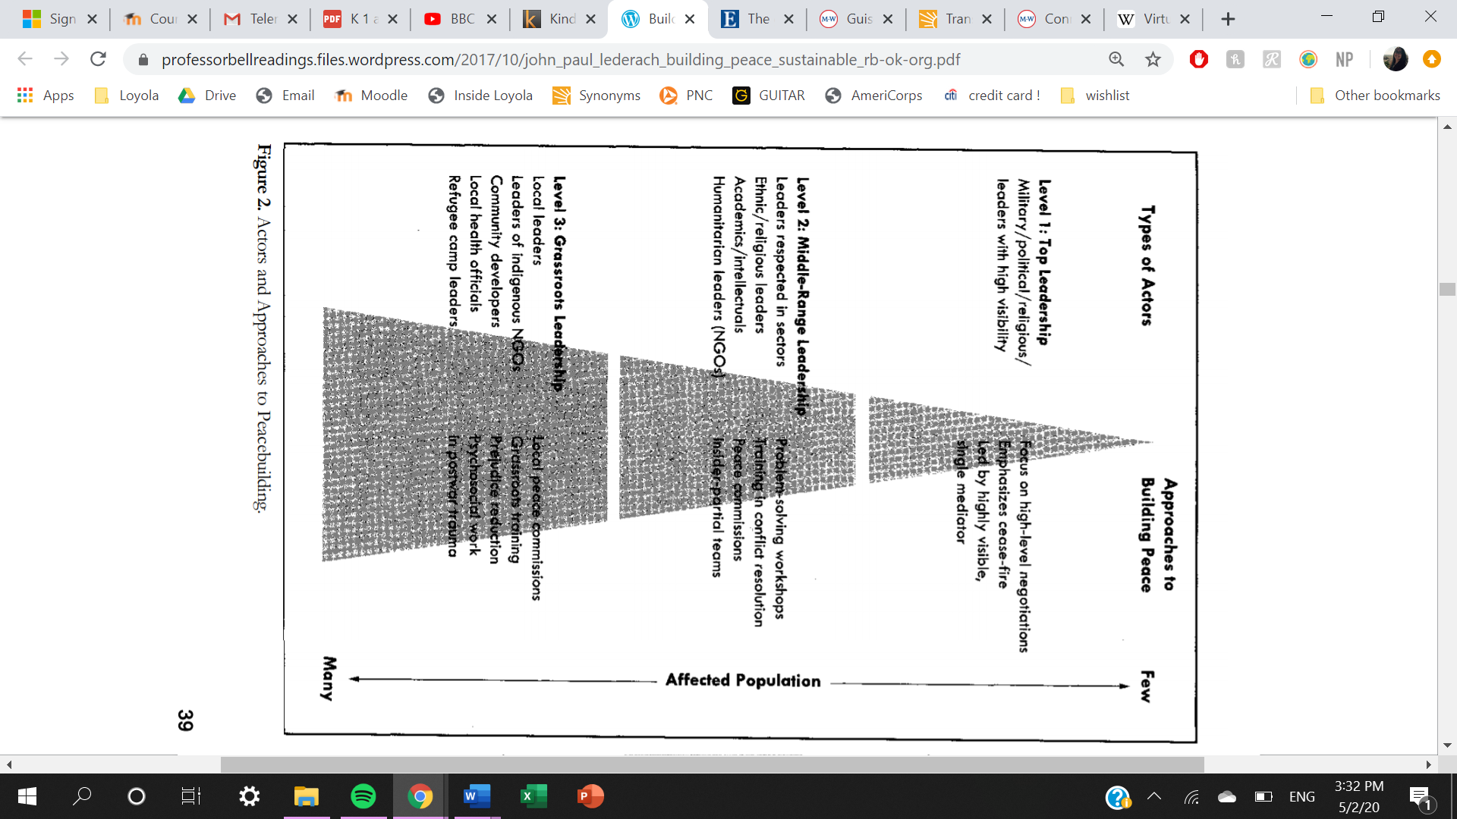

Figure 1. “Actors and Approaches to Peacebuilding” framework.[26]

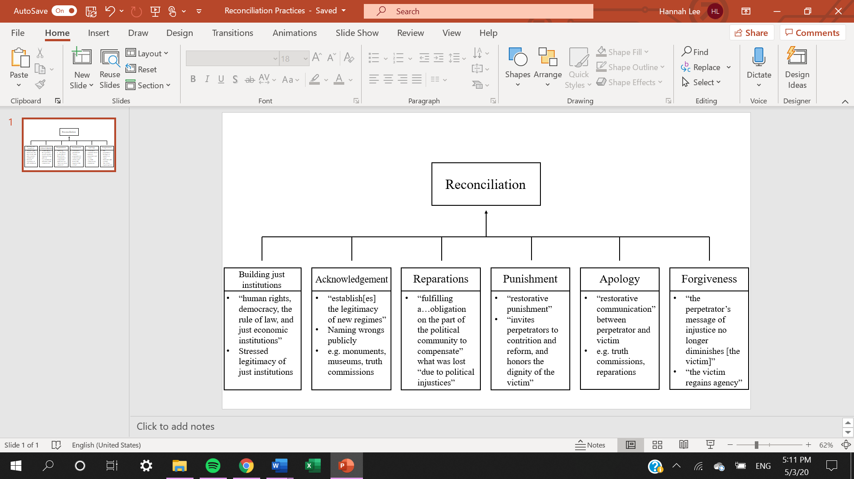

Figure 2. “Six Practices to Promote Reconciliation as a Conception of Justice” framework.[27]

Lederach’s structure lacks the horizontal connectedness through which both the Philpott and Roman models function. In Philpott’s framework, each of the six practices is rooted in justice. Within justice, each practice also addresses the many “dimension[s] of woundedness” that arise out of political injustice.[28] These things considered, there is an overarching, collective notion in which all these practices are connected. Similarly, in the Roman structure, tradition and order connect all of the spheres of one’s life, independent of class. These two structures, therefore, offer a more comprehensive, holistic approach to peacemaking.

On the other hand, Lederach’s framework is strictly vertical in that it is a “‘trickle-down’ approach to peace.” Of course, there are benefits to a top-down framework. Lederach explains,

According to this model, the greatest potential and the primary responsibility for achieving peace resides with the representative leaders of the parties to the conflict. If these leaders can agree, that sets the stage, the framework, and the environment for delivering the rest of society in the implementation of the agreement that will end the war.[29]

Undoubtedly, this framework effectively connects all levels of leadership in society to peacemaking. However, there is no underlying connection across all levels besides the ultimate goal of peacemaking. This is not necessarily a weakness in Lederach’s framework, but it could be improved by a more holistic perspective. Having some notion that connects all respective spheres/levels/practices strengthens the structure’s likelihood to success as a peacemaking instrument. It not only represents a more comprehensive mission, but it also gives each sphere/level/practice a meaningful part toward and each actor a certain drive for and role in peacemaking.

From these comparisons it is evident that the Roman structure is both horizontal and vertical. This is an aspect of the Roman framework that both Lederach and Philpott can benefit. Vertically, those with the most power were obligated to contribute more toward peacemaking. Therefore, they are responsible for assuring that order is assumed across the empire. The majority of Roman society, who cannot contribute on the same scale that the minority can towards peacemaking, obligate themselves to follow traditional values and practices and therefore contribute to order in their own way. Horizontally, as we have seen, traditional morals and practices connect all Romans to each other as a united people. No matter the social class, each Roman understands that they are a part of and committed to the superior people in their known world. A framework that connects, unites, and/or empowers all players can be more effective.

With these things considered, it is important to note the importance of analyzing history, specifically antiquity, in peace studies. At face value, it seems that ancient societies, like Rome, offer little help in peace studies today. However, it is from these very societies that we have evolved. The Romans and Greeks set off the beginning developments of Western culture and civilizations. Their knowledge and influence (in humanities especially) are responsible for where we are today. Within this pool of ancient knowledge, peace studies can thrive.

There are plenty other aspects within Roman history, knowledge, and ideologies that peace studies can further benefit. For example, many Romanized schools of Hellenistic philosophy, Cicero’s interpretations of just war theory, and Roman mythology offer aspects of peace and war that could contribute to peace studies. Roman literature and poetry also provide extensive resources we can draw from. Especially in the Augustan Age, for instance, which was marked by great political and social change in the aftermath of the empire’s transition into the Principate, writers reflected on and were inspired by various topics concerning politics, peace, war, justice, and national pride. Peace studies can benefit from history by learning from its mistakes and taking from its achievements. The field can also make adaptations of historical content to apply to current conflicts. Therefore, peace studies can benefit by making use of historical models of navigating peace, or it can take a more interdisciplinary approach in studying *peace* in history.

***

In conclusion, Roman society can be interpreted as an organized structure fueled by tradition and order. By analyzing this structure, we can articulate how the Romans sought peace in their own way. Peace, for the Romans, necessitated order fed by tradition. Each member of society was obligated to establish order in each sphere of their lives. In this paper, the spheres of family, society, and state were explored to emphasize that each sphere is intimately connected. If too many members of society were to have neglected their obligations to each of the spheres in their lives, society would become disorderly. Peace studies today can use this organization of Roman society as a tool to engage in more holistic measures in building peace. Antiquity, and history in general, offers an almost infinitely vast pool of knowledge that peace studies has yet to explore wholly and thoughtfully. Many new advancements in peace studies might even be waiting for us in the many texts from antiquity.

Bibliography

Champion, Craig B. *The Peace of the Gods: Elite Religious Practices in the Middle Roman*

*Republic*. Princeton, NJ: Princeton University Press, 2017.

Dixon, Suzanne. *The Roman Family*. Baltimore, MD: The Johns Hopkins University Press, 1992.

Earl, Donald. *The Moral and Political Tradition of Rome*. Ithaca, NY: Cornell University Press,

1967.

Gorman, Robert F. “Citizenship, Obligation, and Exile in the Greek and Roman Experience.”

*Public Affairs Quarterly* 6 (January 1992): 5-22.

Harrer, G.A. “Cicero on Peace and War.” *The Classical Journal* 14 (October 1918): 26-38.

Lederach, John Paul. *Building Peace: Sustainable Reconciliation in Divided Societies*.

Washington, D.C.: United States Institute of Peace Press, 1997.

Philpott, Daniel. “Reconciliation: An Ethic for Peacebuilding.” *Strategies of Peace:*

*Transforming Conflict in a Violent World* (Kindle Version). Edited by Daniel Philpott and Gerard F. Powers, 91-113. Oxford, England: Oxford University Press, 2010.

Rea, Jennifer A. and Liz Clarke.. *Perpetua’s Journey: Faith, Gender, and Power in the Roman*

*Empire*. New York, NY: Oxford University Press, 2018.

Toner, Jerry. *Roman Disasters.* Cambridge, England: Polity Press, 2013.

Vibia Perpetua. *The Passion of Perpetua and Felicity*. *Perpetua’s Journey: Faith, Gender, and*

*Power in the Roman Empire*. Edited by Jennifer A. Rae and Liz Clarke, 172-181. New

York, NY: Oxford University Press, 2018.

1. Jennifer A. Rae and Liz Clarke, *Perpetua’s Journey: Faith, Gender, and Power in the Roman Empire* (New York, NY: Oxford University Press, 2018), 146.
2. Ibid, 146.
3. Suzanne Dixon, *The Roman Family* (Baltimore, MD: The Johns Hopkins University Press, 1992), 41, 40.
4. Vibia Perpetua, *The Passion of Perpetua and Felicity*, *Perpetua’s Journey: Faith, Gender, and Power in the Roman Empire*. Ed., Jennifer A. Rae and Liz Clarke(New York, NY: Oxford University Press, 2018), 174: 5.2-4.
5. Ibid, 117.
6. Dixon, 109.
7. Ibid, 110.
8. Craig B. Champion, *The Peace of the Gods: Elite Religious Practices in the Middle Roman Republic* (Princeton, NJ: Princeton University Press, 2017), 8.
9. Robert F. Gorman, “Citizenship, Obligation, and Exile in the Greek and Roman Experience,” *Public Affairs Quarterly* 6 (January 1992): 14.
10. Champion, xi.
11. Jerry Toner, *Roman Disasters* (Cambridge, England: Polity Press, 2013), 59.
12. Champion, 21.
13. Ibid, xiii.
14. Ibid, 130.
15. Ibid, 132, 141.
16. Ibid, 10.
17. Donald Earl, *The Moral and Political Tradition of Rome* (Ithaca, NY: Cornell University Press, 1967), 69.
18. Ibid, 34, 31.
19. Ibid, 83.
20. Ibid, 35.
21. Ibid, 41.
22. G.A. Harrer, “Cicero on Peace and War,” *The Classical Journal* 14 (October 1918): 30.
23. Ibid, 31 or Cicero’s *Epistulae ad Quintum Fratrem* (I.11.34).
24. Ibid, 31 or Cicero’s *De republica* (III.29.41).
25. Daniel Philpott, “Reconciliation: An Ethic for Peacebuilding,” *Strategies of Peace: Transforming Conflict in a Violent World* (Kindle Version). Ed., Daniel Philpott and Gerard F. Powers (Oxford, England: Oxford University Press, 2010), 92.
26. John Paul Lederach, *Building Peace: Sustainable Reconciliation in Divided Societies* (Washington, D.C.: United States Institute of Peace Press, 1997), 39.
27. Philpott, 104-113. Visualized structure made and titled by Hannah Lee.
28. Philpott, 104.
29. Lederach, 45.