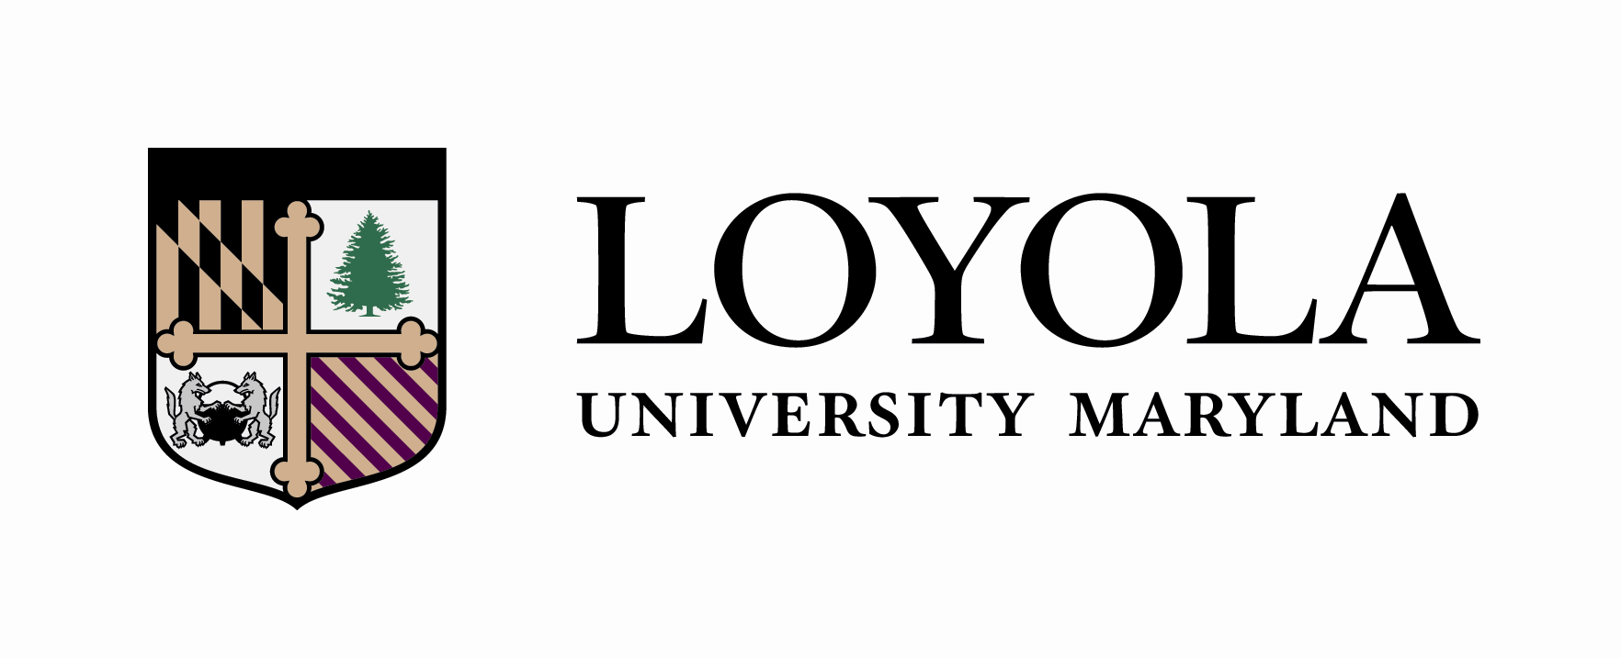

_________________________________________ _ 2026______ __________________
Student Name Catalogue Year ID #

SOCIOLOGY (BA)
(Honors Class of 2030)
Liberal Arts Core | Semester Completed
- HN 210 Eloquentia Perfecta
- HN 201 Ancient World
- HN 202 Medieval World
- Take one EN 300-level or EN 400-level course, or one HS 301-399 or 410-498
- PL 321 or above (excluding logic and ethics) or one course above TH 320 (excluding logic and ethics) in Theology
- HN 237 Social Power and Social Change
- SC 100 Introduction to Sociology
- Honors Fine Arts Course
- ST 210 or ST 265
- One Honors science course OR one majors-level science course with lab
- Additional Honors science course, additional majors-level science course, additional 200-level or above math course OR CS151
- HN 203 Renaissance to Modern
- HN 204 Modern World
- World Language to the 200-level OR Classical Language 300-level*
- Ethics: HN499 The Examined Life: If you took a PL 320+ course, take HN499 with a TH professor; if you took a TH 320+ course, take HN499 with a PL professor.

Diversity and Justice Course**
Diversity and Justice Course**

*Students who place higher than the 104 level on Loyola’s world language placement exam may be exempt from the world language core requirement, pending confirmation from Loyola’s Modern Language department after a proctored on-site placement exam. Those students will need to complete 1 additional free elective in lieu of the world language core.

**The Diversity and Justice course requirements may simultaneously fulfill a Core, Major, Minor or Elective requirement. The Diversity and Justice courses may be taught in any discipline and will focus on domestic diversity, global diversity, or justice awareness. The Diversity and Justice courses must be taken at Loyola.

Sociology | Semester Completed
- SC 342 Social Research Methods (FA only)
- SC 355 Sociological Theory (SP only)
- SC 2** Level or Higher
- SC 3** or 4*** Level
- SC 3** or 4*** Level
- SC 3** or 4** Level
- SC 3** or 4** Level
- SC 4** Level Seminar
- Choose 1: SC 400 Independent Scholarship Capstone OR
SC 401 Sociology Practicum (SP only) OR
SC 402 Social Work Practicum (SP only)
- Choose 1: CM 312 CM 314 CM 324 CS 105
CS 106 CS 151 PY 292 SC 214 SC 309
SC 398 SC 415 SC 416
Free Electives | Semester Completed
- Free Elective
- Free Elective
- Free Elective
- Free Elective
- Free Elective
- Free Elective
- Free Elective
- Free Elective
- Free Elective
- Free Elective
- Free Elective
- Free Elective
- Free Elective
- Free Elective
- Free Elective
Loyola sociology courses cohere in five conceptual groupings. Students are encouraged to consult with their advisors for assistance selecting courses that support their career choice. The sociology course groupings are:
Deviance, Crime, and Institutions of Social Control
Power and Inequality in Community, Health, and Education
Social Conflicts, Movement, and Change
Culture and Identity in Societal Context
Family and Human Services

*Only two 200-level sociology courses may count towards the major.

*Students must complete one 400-level seminar as part of the major requirements. SC 400, SC 401, SC 402, SC 415, and SC 416 do not fulfill the requirement.

*Only two semesters of supervised study (research or readings) may count towards the major.

