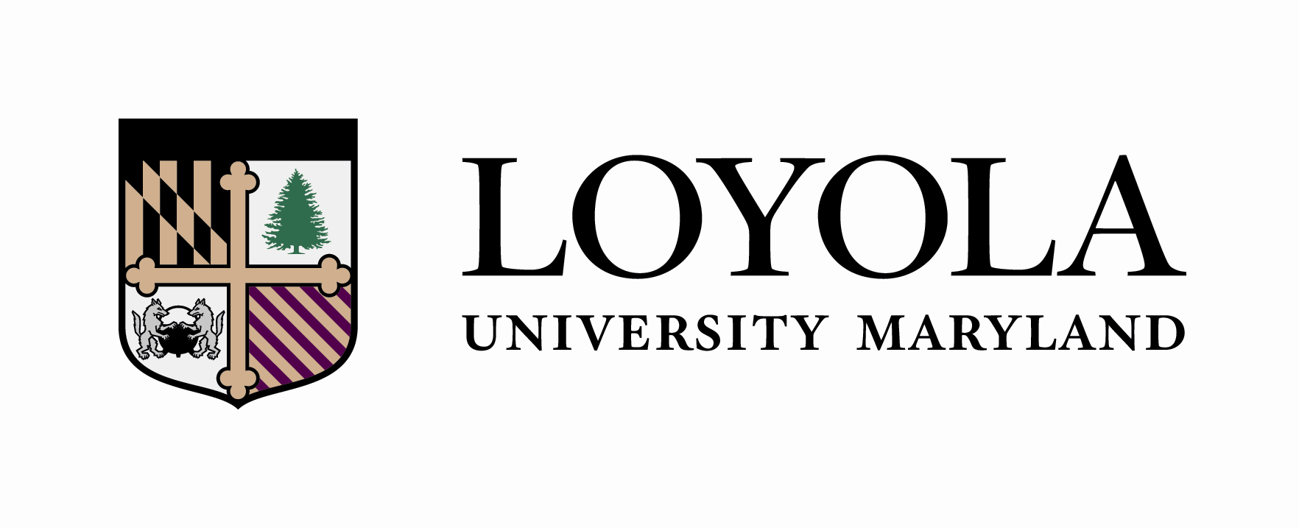

_________________________________________ _ 2026_____ __________________
Student Name Catalogue Year ID #

PSYCHOLOGY (BA)
(Honors Class of 2030)
Liberal Arts Core | Semester Completed
- HN 210 Eloquentia Perfecta
- HN 201 Ancient World
- HN 202 Medieval World
- Take one EN 300-level or EN 400-level course, or one HS 301-399 or 410-498
- PL 321 or above (excluding logic and ethics) or one course above TH 320 (excluding logic and ethics) in Theology
- HN 232 Honors Seminar: Introductory Psychology
- PY 200-level course (excluding PY291 or PY292)
- Honors Fine Arts Course
- ST 265 or ST210 (Take Freshman year)
- BL 105 or BL 152/153
- Additional Honors science course, additional majors-level science course, additional 200-level or above math course OR CS151
- HN 203 Renaissance to Modern
- HN 204 Modern World
- World Language to the 200-level OR Classical Language 300-level*
- Ethics: HN499 The Examined Life: If you took a PL 320+ course, take HN499 with a TH professor; if you took a TH 320+ course, take HN499 with a PL professor.

Diversity and Justice Course**
Diversity and Justice Course**

*Students who place higher than the 104 level on Loyola’s world language placement exam may be exempt from the world language core requirement, pending confirmation from Loyola’s Modern Language department after a proctored on-site placement exam. Those students will need to complete 1 additional free elective in lieu of the world language core.

**Students may elect to take EC220 instead of ST110, ST210, or ST265. If EC220 is selected, the math core requirement must still be fulfilled.

***The Diversity and Justice course requirements may simultaneously fulfill a Core, Major, Minor or Elective requirement. The Diversity and Justice courses may be taught in any discipline and will focus on domestic diversity, global diversity, or justice awareness. The Diversity and Justice courses must be taken at Loyola.

Psychology Major | Semester Completed
- Breadth and Depth: Learning, Cognition and Behavioral Neuroscience:
Choose One: PY 221 PY 222 PY 223 PY 224
PY 225 PY 332 PY 422
- Breadth and Depth: Developmental Psychology:
Choose One: PY 205 PY 244 PY 341 PY 342 PY 343
PY 423 PY 445
- Breadth and Depth: Social and Personality Psychology:
Choose One: PY 201 PY 203 PY 262 PY 351 PY 365
PY 424
- Breadth and Depth: Clinical, Counseling and Health Psychology:
Choose One: PY 202 PY 261 PY 323 PY 325 PY 326
PY 425 PY 430
- Information and Quantitative Literacy: PY 291**

Info. and Quantitative Literacy courses that may be taken as PY electives or Mastery Courses (400-level) towards the major: PY 310 PY 401 PY 402 PY 405 PY 406
PY 418 PY 419 PY 426

- Information and Quantitative Literacy: PY 292**

Info. and Quantitative Literacy courses that may be taken as PY electives or Mastery Courses (400-level) towards the major: PY 310 PY 401 PY 402 PY 405 PY 406
PY 418 PY 419 PY 426

- Diversity, Ethics, and Justice:
Choose One: PY 253 PY 270 PY 354 PY 355
PY 404 PY 410 PY 415 PY 427

Professional Readiness: PY 200 (1 cr.)***

Professional Readiness courses that may be taken as PY electives or Mastery Courses towards the major:
PY 435 PY 436
- Mastery Course:
One 400-level PY course
- Mastery Course:
One 400-level PY course
- Elective Course:
Choose One PY 100/200/300/400 level course from any group
- Elective Course:
Choose One PY 100/200/300/400 level course from any group
- Elective Course:
Choose One PY 100/200/300/400 level course from any group
Electives | Semester Completed
- Free Elective
- Free Elective
- Free Elective
- Free Elective
- Free Elective
- Free Elective
- Free Elective
- Free Elective
- Free Elective
- Free Elective
- Free Elective
- Free Elective
- Free Elective

**Students are required to take PY 291 (4 cr.) and PY 292 (4 cr.) for the psychology major.

***Students are required to take PY 200 (1 cr.) for the psychology major.

