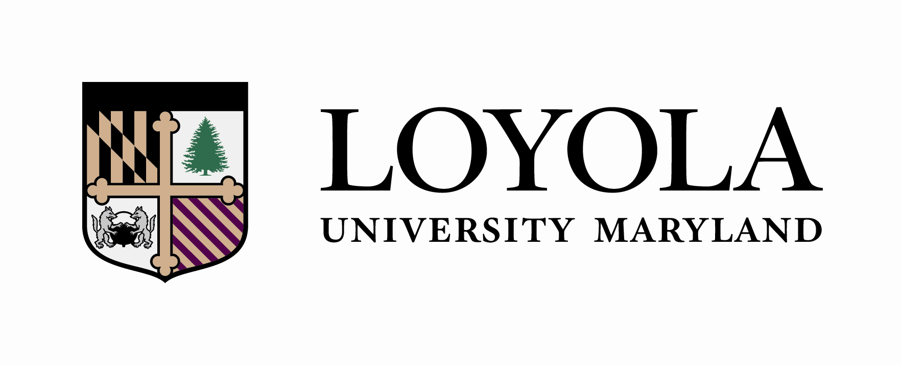

_________________________________________ _ 2026______ __________________
Student Name Catalogue Year ID #

ENGLISH (BA)
(Class of 2030)
Liberal Arts Core | Semester Completed
- HN 210 Eloquentia Perfecta
- HN 201 Ancient World
- HN 202 Medieval World
- Take one EN 300-level or EN 400-level course
- PL 321 or above (excluding logic and ethics) or one course above TH 320 (excluding logic and ethics) in Theology
- HN Social Science Seminar
- HN Social Science Seminar or a standard Social Science Core (Social Science course from EC, PS, PY, or SC at the 100 Level or SC 201, 202, 203, 204, 205, 206, 207 or 209. (Psychology may be taken at the 100 or 200 Level))
- Honors Fine Arts Course
- Math Core (MA251, ST210 or ST265)
- One Honors science course OR one majors-level science course with lab
- Additional Honors science course, additional majors-level science course, additional 200-level or above math course OR CS151
- HN 203 Renaissance to Modern
- HN 204 Modern World
- World Language to the 200-level OR Classical Language 300-level*
- Ethics: HN499 The Examined Life: If you took a PL 320+ course, take HN499 with a TH professor; if you took a TH 320+ course, take HN499 with a PL professor.

Diversity and Justice Course**
Diversity and Justice Course**

*Students who place higher than the 104 level on Loyola’s world language placement exam may be exempt from the world language core requirement, pending confirmation from Loyola’s Modern Language department after a proctored on-site placement exam. Those students will need to complete 1 additional free elective in lieu of the world language core.

**The Diversity and Justice course requirements may simultaneously fulfill a Core, Major, Minor or Elective requirement. The Diversity and Justice courses may be taught in any discipline and will focus on domestic diversity, global diversity, or justice awareness. The Diversity and Justice courses must be taken at Loyola.

English | Semester Completed
- EN Pre-1800 (EN 300-339; 407; 411-439)
- EN Pre-1800 (EN 300-339; 407; 411-439)
- EN Pre-1800 (EN 300-339; 407; 411-439)
- EN 19th Cent. Lit. (EN 350-369; 450-469)
- EN 20th and 21st Cent. Lit (EN 370-399; 470-499)
- EN Elective 300 – 499
- EN Elective 300 – 499
- EN Elective 300 – 499
- EN Elective 300 – 499
- EN Elective 300 – 499
Electives | Semester Completed
- Free Elective
- Free Elective
- Free Elective
- Free Elective
- Free Elective
- Free Elective
- Free Elective
- Free Elective
- Free Elective
- Free Elective
- Free Elective
- Free Elective
- Free Elective
- Free Elective
- Free Elective

*Two of the required major courses must be seminars (EN 400-level).

*An honors option, involving a seminar and a thesis, is available to qualified seniors. Students are invited to enroll in EN 430, EN 450, and EN 470 at the close of their junior year. The seminar counts as an upper-level seminar in the major. Each year the chair determines, on the basis of course material, which seminars will be offered.

